**Project Plan**

**ThymeShare App**

|  |  |
| --- | --- |
| Team Member | Trevor Rocha |
| Team Member | Derek So |
| Team Member | Magomed Alimuradov |
| Team Member | Kartik |

Document Revision History

|  |  |
| --- | --- |
| Revision # | Date |
| 0 | 10/08/20 |

**Table of Contents**

Executive Summary3

Project Approvers, Reviews and Distribution List3

Scope4

Deliverables 4

Dependencies 5

Risk Management 5

Communication 5

Task Listing 6

Milestones 6

RAM – Responsibility Assignment Matrix7

Approval8

**1. Executive Summary**

The following describes the project to be executed.

|  |  |
| --- | --- |
| Objective | A cookbook app where you can add your own recipes, and the app will suggest recipes you might like based on what you have added. The more recipe the user adds, the more recipes they will be suggested and can see. Users will be suggested to other users’ recipes and will have the ability to like, bookmark, and comment on recipes. The app can also show you where to get ingredients around you, whether by pointing you to stores or by suggesting ways to get it delivered. This is at its core a personalized cookbook with social media features. |
| Planned Start Date | September 21, 2020 |
| Planned End Date | April 2, 2020 |

**2. Project Approvers, Reviews and Distribution List**

Approvers, reviewers and distribution list

|  |  |  |  |
| --- | --- | --- | --- |
| Project Role | Name | E-mail | Date |
|  | Trevor Rocha | [Trevorrocha@gmail.com](mailto:Trevorrocha@gmail.com) | 10/11/20 |
|  | Derek So | Derek.so@georgebrown.ca | 10/11/20 |
|  | Magomed Alimuradov | [Magomed.Alimuadov@georgebrown.ca](mailto:Magomed.Alimuadov@georgebrown.ca) | 10/11/20 |
|  | Kartik | Kartik@georgebrown.ca | 10/11/20 |
|  |  |  |  |
|  |  |  |  |

**3. Scope**

Define the sum total of all of its products and their requirements or features.

|  |  |
| --- | --- |
| In Scope | Out of Scope |
| Mobile development app | GPS for Maps |
| Storage system |  |
| Internet access (?) |  |
| User information encryption |  |

**4. Deliverables**

This project will deliver the following.

|  |  |
| --- | --- |
| Deliverable | Description |
| Storing of recipes | The Application will allow the user to input recipes and save them on the app |
| Suggesting recipes | The application will suggest recipes based off the ones you have stored, saved, shared, and have ingredients for. |
| Storing user ingredients | Allows the user to quickly store ingredients for the purpose of having a quick access to see what ingredients you need for a recipe |
| Creation of shopping list | Allow the user to push items from recipes they do not have to a shopping list |
| Social media functions (liking, sharing, etc.) | Having social media functions will allow the user to be suggested more recipes that are related to the food they like |

**6. Dependencies**

* GitHub
* Discord
* Travis
* Visual studio
* Android studio
* Database
* Jira

**7. Risk Management**

|  |  |  |  |
| --- | --- | --- | --- |
| Potential Risk | Severity (H/M/L) | Likelihood (H/M/L) | Management Strategy |
| Loss of information | L | L | Keep backups in case of error |
| Server Failure | L | L | Maintain information on how the server is running |
| Bugs | M | M | Be ready to create and push out update to keep the app running |

**8. Communication**

**Reporting**

The following reports will be produced.

|  |  |  |
| --- | --- | --- |
| Report | Audience | Frequency |
| Progression Report | Whole Team | Monday/Thursday |

**Meetings**

The following meetings/communication will be established.

|  |  |  |  |
| --- | --- | --- | --- |
| Meeting | Purpose | Attendees | Frequency |
| Monday | Weekly discussion | Full team | Every week |
| Thursday | Weekly discussion | Full team | Every week |

**9. Task Listing (WBS- Work Breakdown Structure)**

The following resource proposal template summarizes the resource hours committed to this project, upon final approval of this document.

|  |  |  |  |
| --- | --- | --- | --- |
| Reference | Tasks | Duration | Dependency |
| A | Sprint 1 | 2 Weeks | Team members |
| B | Sprint 2 | 2 Weeks | Team members |
| C | Project Presentation | 4 Days | Team members |
| D | Sprint 5 | 2 Weeks | Team Members |
| E | Sprint 6 | 2 Weeks | Team members |
| F | Sprint 7 | 2 Weeks | Team members |
| G | Sprint 8 | 2 Weeks | Team members |
| H | Sprint 9 | 2 Weeks | Team members |

**10. Milestones**

|  |  |  |
| --- | --- | --- |
| Major Activity or Milestone | Estimated Milestone Target date | Owner/Reviewer Team Members |
| Sprint 1   * Updated/Revised Project Summary * Project Vision * High-Level Requirements * Personas and User stories | 10/11/20 | Team members |
| Sprint 2   * Project Plan _______ * Team Charter * Minutes of Meeting/s * Product Backlog * Sprint Backlog | 10/11/20 | Team members |
| Project Presentation | 10/15/20 | Team members |
| Sprint 5   * Update Project Plan * Minutes of Meeting/s * Project Status Report 1 | 01/11/21 | Team Members |
| Sprint 6   * Project Status Report 2 | 01/31/21 | Team Members |
| Sprint 7   * System Implementation 1 Demo * Presentation | 02/15/21 | Team Members |
| Sprint 8   * Project Status Report 2 | 02/28/21 | Team Members |
| Sprint 9   * System Implementation 2 Complete Project * Presentation * Completion Report | 03/01/21 | Team Members |

**11. RAM – Responsibility Assignment Matrix**

**Sprint 1**

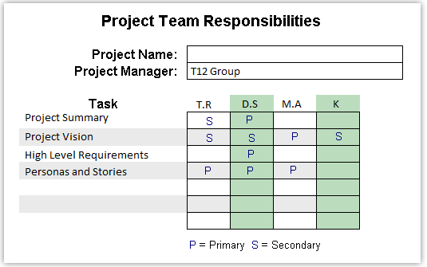

**Sprint 2**

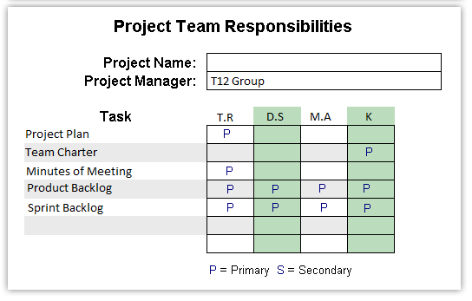

**Sprint 5**

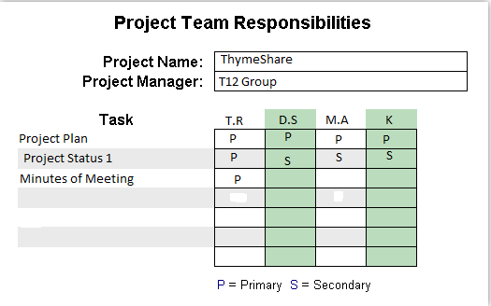

**12. Approval**

The signatures below indicate their approval of the contents of this document.

|  |  |  |
| --- | --- | --- |
| Name | Signature | Date |
| Trevor Rocha | Trevor Rocha | 10/11/20 |
| Derek So | Derek So | 10/11/20 |
| Magomed Alimuradov | Magomed Alimuradov | 10/11/20 |
| Kartik | Kartik | 10/11/20 |